**BLOG CREATION**

**AIM:**

   To create a blog and publish the content.

**ALGORITHM:**

**Step 1 :** Open the browser and type [login.wix.com](http://login.wix.com/).

**Step 2** : Make sign into the website.

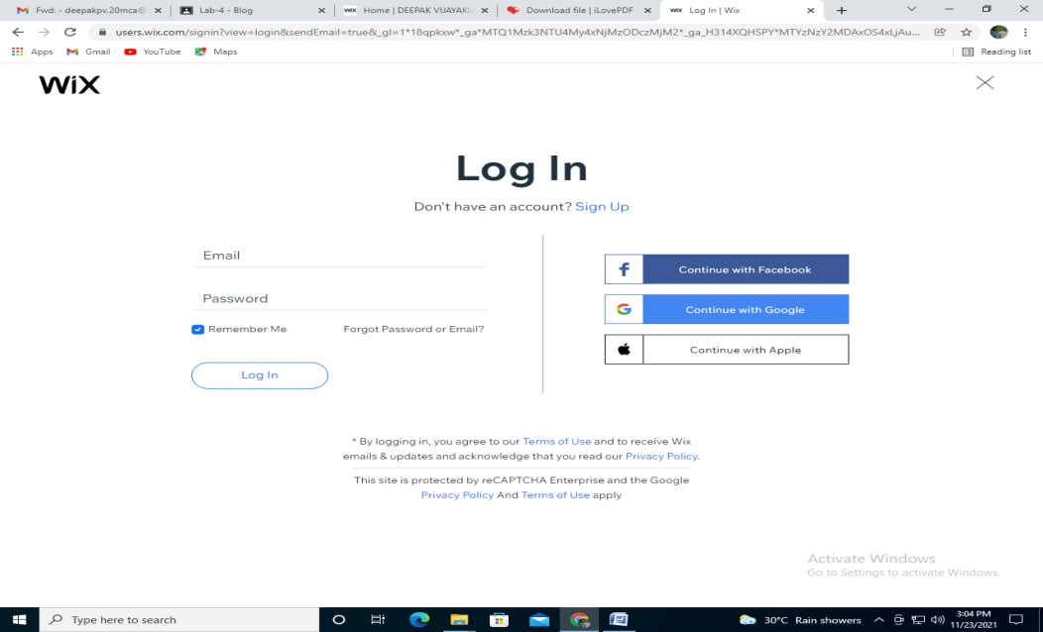

**Step 3** : Create new post in left top corner.

**Step 4**:  Create own content.

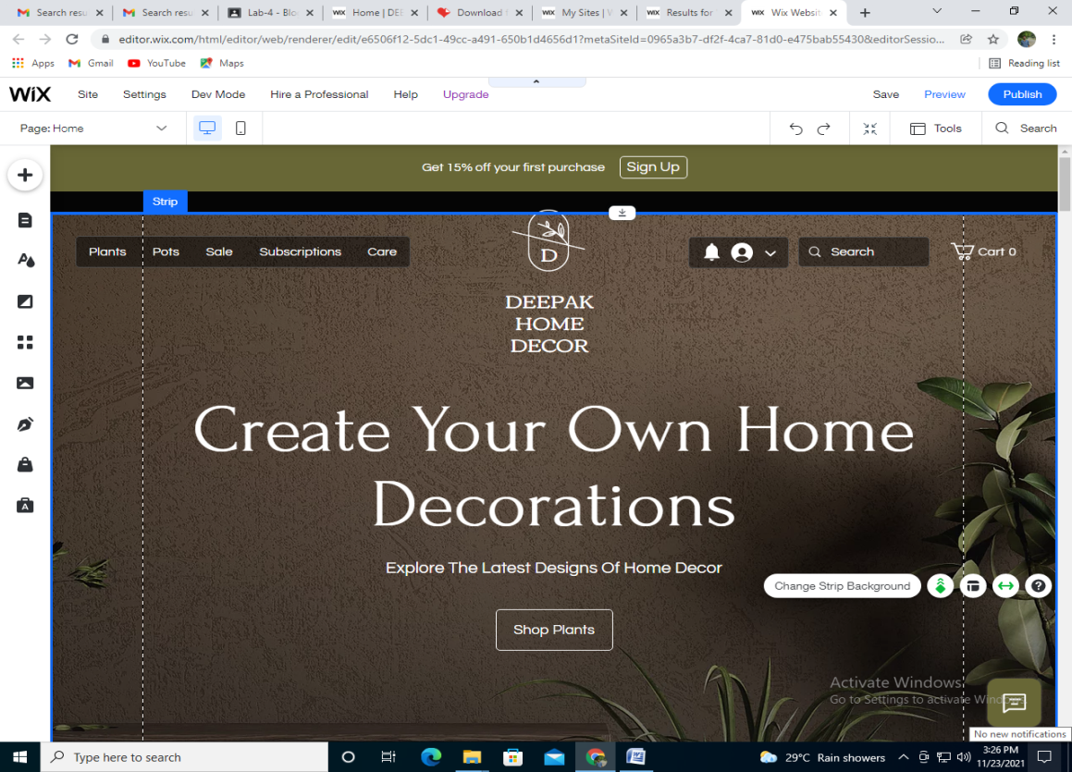

**Step 5**: Once finished, click preview button in right top corner.

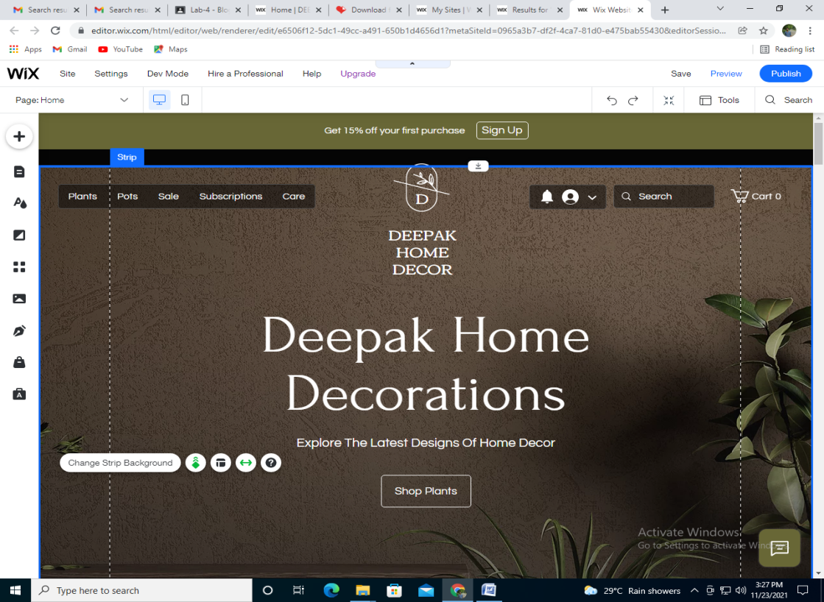

**Step 6**: Preview of the content will be displayed.

**Step 7**: Click the button publish.

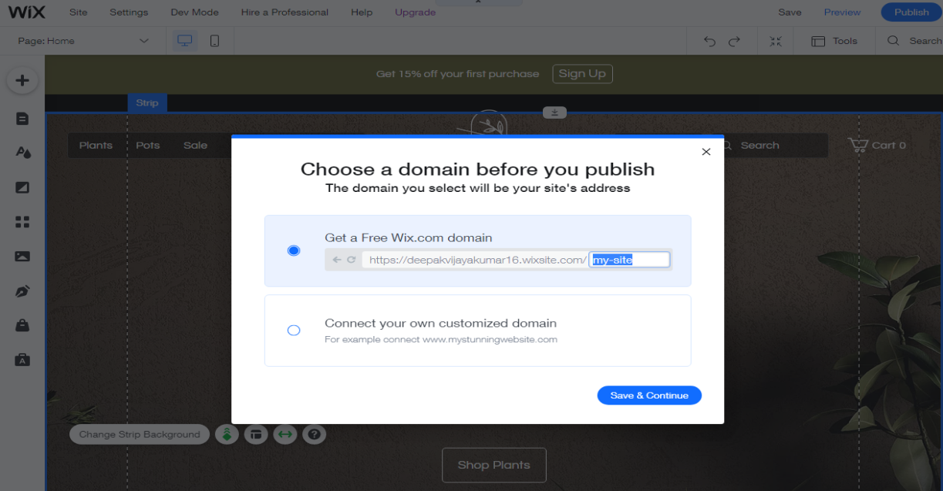

**Step 8**: By clicking the publish button,the content created will be published.

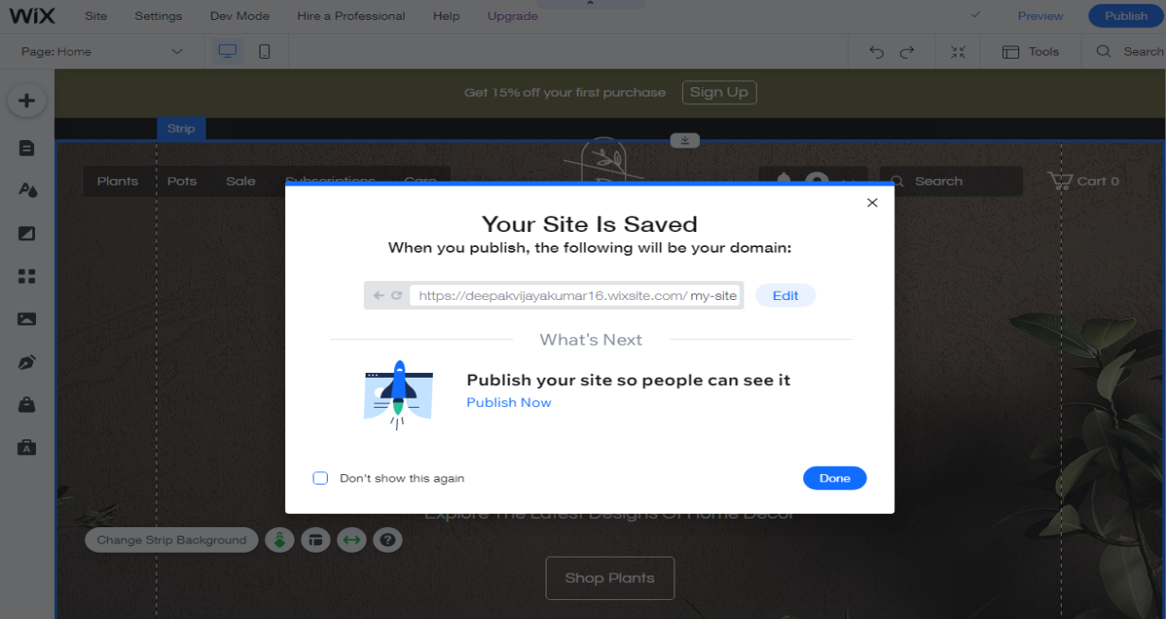

**Step 9**: The changes of the time for the content are available in left side of the web page.

**Step 10**: The content published can be edit at any time.